THE RICHARD S. HODES, M.D.
HONOR LECTURE AWARD

2021

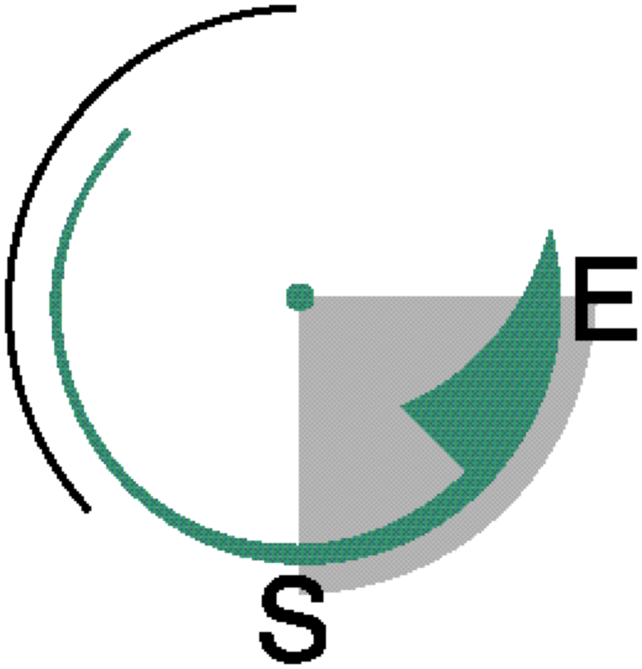

NOMINATION PACKET
____________________________________________

THE RICHARD S. HODES, M.D. HONOR LECTURE AWARD honors the memory of its late chairman, Dr. Richard S. Hodes, a strong proponent for innovation in the field of low-level radioactive waste management. Dr. Hodes was a physician, statesman, educator, and chairman for 19 years of the Southeast Compact Commission for Low-Level Radioactive Waste Management. The award was created by the Commission to encourage environmental professionals and political leaders to develop innovative approaches to waste management in the United States and, in doing so, to further the mission and objectives of the Southeast Compact Commission.

THE DEADLINE FOR NOMINATIONS IS AUGUST 31, 2020.

Inquiries about the Richard S. Hodes, M.D. Honor Lecture Award should be directed to:

Ted Buckner, Executive Director
Southeast Compact Commission
Post Office Box 5427
Cary, NC 27512
Email: tedb@secompact.org or visit the Commission web site at www.secompact.org.

__________

RICHARD S. HODES, M.D.
______________

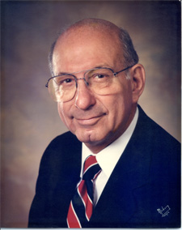
Dr. Richard S. Hodes (1921-2002) was a distin-guished statesman and a lifetime scholar. A graduate of Tulane University School of Medicine, Dr. Hodes was an anesthesiologist in private practice for more than forty years in Tampa, Florida. He served as Professor and Chairman of the Department of Anesthesiology at the University of South Florida and was Clinical Director for Florida Medical Quality Assurance. He served terms as president of the Florida Medical Association, the Hillsborough County Medical Association, and the Florida Society of Anesthesiologists.

Dr. Hodes served six terms in the Florida House of Representatives, was Majority Leader in 1980-1982 and Speaker pro tempore in 1978-1980, and was President of the National Conference of State Legislatures in 1980-1981.

In 1981, Dr. Hodes represented the State of Florida as one of the negotiators who crafted legislation that eight state legislatures would enact to create the Southeast Compact, in itself an innovative approach to public policy in waste management. In 1983, he was appointed as one of the first Commissioners from Florida to the Southeast Compact Commission for Low-Level Radioactive Waste Management. He was elected by his peers to serve as the chair of the Southeast Compact Commission from its inception in 1983 until his death in 2002. For 19 years, he guided the Commission through numerous challenges with courage, wisdom, and integrity.

Throughout his career, Dr. Hodes developed and supported innovation in medicine, law, public policy, and technology. He constantly sought and implemented better, more creative ways to solve problems and encouraged others to do the same.

THE RICHARD S. HODES, M.D.

HONOR LECTURE AWARD

The Award
The Richard S. Hodes Honor Lecture Award—established in March, 2003—is awarded to an individual, company, or organization that contributed in a significant way to improving the technology, policy, or practices of low-level radioactive waste management in the United States. The award recipient will be recognized with a special plaque and an invitation to present a lecture about the innovation during the 2020 Waste Management Conference in Phoenix, Arizona. A special time is reserved during the Conference for the lecture and the award presentation. The Southeast Compact Commission will provide the award recipient a $5,000 honorarium and will pay travel expenses and per diem (in accordance with Commission Travel Policies) for an individual to present the lecture.

Criteria
The Richard S. Hodes Honor Lecture Award recognizes innovation industry-wide. The award is not limited to any specific endeavor—contributions may be from any type of work with radioactive materials (nuclear energy, biomedical, research, etc.), or in any facet of that work, such as planning, production, maintenance, administration, or research. The types of innovations to be considered include, but are not limited to:

- Conception and development of new approaches or practices in the prevention, management, and regulation of radioactive waste;
- New technologies or practices in the art and science of waste management; and
- New educational approaches in the field of waste management.

The criteria for selection include:
- Innovation. Is the improvement unique? Is it a fresh approach to a standard problem? Is it a visionary approach to an anticipated problem?
- Safety. Does the practice enhance radiation protection?
- Economics. Does the approach produce significant cost savings to government, industry or the public?
- Transferability. Is this new practice applicable in other settings and can it be replicated? Does it increase the body of technical knowledge across the industry?

Eligibility
To be eligible for the award, the individual/group must consent to being nominated and must be willing to prepare and present a lecture about the innovation being recognized at the Waste Management Symposium. Individuals or organizations can nominate themselves or another individual, company, institution, or organization.

THE RICHARD S. HODES, M.D.

HONOR LECTURE AWARD

RECENT AWARDS

2020 Recipient

Savannah River Remediation LLC. The Commission recognized Savannah River Remediation LLC (SRR) as the seventeenth recipient of the Richard S. Hodes Award for developing and implementing a technical, regulatory, and engineering strategy to work with the U.S. Department of Energy (DOE) for the removal and treatment of liquid radioactive waste associated with reprocessing in a manner that allows its disposition as other than high-level waste.

SRR combined progressive waste processing policies with state-of the-art technologies to reclassify high-level wastes and then contain them for permanent disposal as low-level radioactive waste (LLRW). Using these innovative methodologies, SRR was able to save taxpayers over $55 billion. Additionally, many of the innovative solutions developed by SRR are directly transferable to others for solving complex issues with treatment and disposition of complex radioactive waste streams.

2019 Recipient

Clint Miller. The Commission recognized Mr. Miller as the sixteenth recipient of the Hodes Honor Lecture Award for the significant role he has played in solving low-level radioactive waste management challenges in the United States. He has successfully pioneered and championed innovative waste management techniques that resulted in reduced generation of waste and improved management of liquid effluents in nuclear power plants. Additionally, he has widely shared his innovations with the industry to further enable other plants to adopt these best-in-the-industry radwaste management practices.

Mr. Miller has 38 years of experience in the radwaste industry and has spent the last 34 years with Pacific Gas & Electric. He is Chair of the radwaste operation subcommittee of the ASME, a WMS Fellow, and a registered Professional Engineer. He holds a BS in Nuclear Engineering from University of Illinois and a MS in Energy Systems from the University of Arizona.

2018 Recipient

The National Nuclear Security Administration (NNSA) and the Off-Site Source Recovery Program (OSRP) is a U.S. Department of Energy (DOE) program that has for 20 years recovered and disposed of disused radioactive sources that pose a potential threat to national security, public health, and safety. It contributes to national security by eliminating from the environment excess radioactive sources that could be used in a Radiological Dispersion Device or for any other malicious purposes. The program is part of NNSA’s Office of Radiological Security.

The Commission recognized NNSA-OSRP for as the fifteenth recipient of the Hodes Honor Lecture Award the program’s innovative efforts in solving low-level radioactive waste (LLRW) management challenges in the United States by:

  - Successfully completing the design, testing and certification of two new Type-B transportation containers to alleviate a shortage of containers that significantly limited the recovery and disposal of commercially licensed sealed sources; and

  - Providing the certified designs to qualified private sector entities to use or modify them to develop containers for commercial use, thereby encouraging and facilitating the development of additional commercial capacity.

2017 Recipient

Scott Kirk. Mr. Kirk has more than 25 years of experience in the nuclear industry and recently joined BWX Technologies, Inc. as a Director of Regulatory Affairs. In this capacity, Scott provides guidance on a variety of regulatory affairs matters, focusing on radioactive waste management. Prior to his employment with BWXT, Scott served as the Vice President of Licensing and Regulatory Affairs for Waste Control Specialists LLC, where he significantly contributed to the successful licensing of the first new regional disposal facility to open in the past 40 years in Andrews County, Texas.

The Commission recognized Mr. Kirk as the fourteenth recipient of the Hodes Honor Lecture Award for his innovative efforts in solving low-level radioactive waste (LLRW) management challenges in the United States by:

- Conceiving and perfecting the idea of placing very low activity LLRW in a near-surface landfill based on a performance assessment that showed the predicted dose did not exceed regulatory limits;
- Proposing a near-surface disposal option for Greater than Class C (GTCC) waste that is currently under consideration by the US Nuclear Regulatory Commission (NRC) and the State of Texas; and
- Submitting an application to the NRC to construct and operate a consolidated interim storage facility for spent nuclear fuel.

In addition, the Commission commends Mr. Kirk for his contribution to the professionalism of health physics and radiation safety programs at the Texas Low-Level Radioactive Waste Disposal Compact’s regional disposal facility in Andrews County, Texas.

2016 Recipient

Louis F. Centofanti, Ph.D. has served as the President and Chief Executive Officer of Perma-Fix Environmental Services, Inc. since February 1991.

The Commission recognized Dr. Centofanti as the thirteenth recipient of the Hodes Honor Lecture Award for his innovative efforts in developing critical new technologies, facilities, and resources for the nuclear industry. His efforts have improved radiation health, safety, and security throughout the nation and provided safe disposition of waste that did not previously have disposal pathways. Most recently, he developed an innovative solution to the domestic commercial production of TC-99m that produces very little secondary waste without the proliferation concerns that accompany the use of enriched uranium.

EARLIER AWARDS

2015 Recipients

The Division of Radiation Control (DRC) of the Utah Department of Environmental Quality. The Commission recognized Utah’s DRC and EnergySolutions as the twelfth recipients of the Hodes Honor Lecture Award for the significant role they played in working to solve LLRW management problems in the United States. The DRC and EnergySolutions worked together to improve radiation health, safety, and security throughout the nation by developing and implementing the Utah Sealed Source License Variance initiative. This creative and collaborative effort clearly exemplifies the spirit and commitment that the Hodes Award is intended to recognize.

2014 Recipient

Electric Power Research Institute (EPRI). The Commission recognized EPRI as the eleventh recipient of the Hodes Honor Lecture Award for the significant role the organization plays in advancing low-level radioactive waste management improvements in the United States. EPRI’s leadership and innovative efforts in developing waste storage guidelines and providing site-specific support for low-level waste programs at nuclear power plants have enhanced public safety, as well as contributed to the efficient management of radioactive waste in the US.

2013 Recipients

James E. Kennedy was recognized as the tenth recipient of the Hodes Honor Lecture Award for his extraordinary leadership and innovation in changing the focus of the NRC’s regulatory framework for the management of radioactive waste to an approach that is directly related to safety and is based on risk assessment and performance requirements.

EnergySolutions, the Utah Department of Environmental Quality (UDEQ), the Conference of Radiation Control Program Directors (CRCPD), and the U.S. Department of Energy’s (DOE) Global Threat Reduction Initiative (GTRI) were also recognized with an honorable mention.

2012 Recipient

Lawrence R. “Rick” Jacobi was recognized as the ninth recipient of the Hodes Honor Lecture Award for developing innovative approaches to the design, siting and operation of low-level waste disposal facilities that strongly influenced later siting efforts in the nation, as well as safe, economical disposal solutions using municipal landfills for disposal of short-lived medical radioactive waste.

2011 Recipient

Christine Gelles was recognized as the eighth recipient of the Hodes Honor Lecture Award for her extraordinary leadership and innovative efforts at DOE that have enhanced public safety and contributed to the efficient management of radioactive waste. She helped establish a strong federal partnership with states and Compacts to address LLRW management concerns.

2010 Recipient

Larry Camper was recognized as the seventh recipient of the Hodes Honor Lecture Award for his leadership and innovative efforts to implement substantial regulatory and management improvements in several key NRC regulatory programs that have enhanced public safety, as well as the efficiency and transparency of those programs.

2009 Recipient

Susan Jablonski was recognized as the sixth recipient of the Hodes Honor Lecture Award for her innovative approach to regulation of radioactive waste disposal in Texas, as well as for her efforts in educating and inspiring science teachers and students the high school and university levels.

2008 Recipient

Michael T. Ryan was recognized as the fifth recipient of the Hodes Honor Lecture Award for his contributions to the nuclear industry in the application of a risk-based approach to the disposal of low-level radioactive waste (LLRW) in the United States.

2007 Recipient

Larry McNamara was recognized as the fourth recipient of the Hodes Honor Lecture Award for his contributions to low-level radioactive waste management in the U.S. through his leadership in the commercialization of mixed waste treatment processes for the nuclear industry

2006 Recipient

The California Radioactive Materials Management Forum (CalRad) was recognized as the third recipient of the Hodes Honor Lecture Award for the organization’s contributions toward solving waste management problems in the Southwestern Compact region and the United States through legislative and regulatory development, innovative legislative and regulatory concepts, public involvement and education, and the creation of a unique partnership among LLRW generators, regulatory agencies, and the private sector.

2005 Recipient

William P. Dornsife was recognized as the second recipient of the Hodes Honor Lecture Award for the role he played in solving low-level radioactive waste management problems in the United States through the development of innovative regulatory and technical concepts and his leadership in radiation safety and education.

2004 Recipients

H. W. “Bud” Arrowsmith was recognized as the first recipient of the Hodes Honor Lecture Award for developing and implementing numerous technical innovations in the field of radioactive waste management, including compaction, incineration, recycling, decontamination, and vitrification.

The Texas A&M University Student Chapter of Advocates for Responsible Disposal in Texas (ARDT) was awarded an Honorable Mention in the 2004 Hodes Award program for its innovation in educational activities related to LLRW management.

NOMINATION FORM

THE 2021 RICHARD S. HODES, M.D.
HONOR LECTURE AWARD

THE DEADLINE FOR SUBMISSION IS AUGUST 31, 2020.

THE COMMISSION ENCOURAGES ELECTRONIC SUBMISSION OF ALL NOMINATION MATERIALS.

Submit nominations to:

Awards Committee
c/o Ted Buckner, Executive Director
Southeast Compact Commission
Post Office Box 5427
Cary, NC 27512-5427

Phone: (919) 360-6040
Email: secc@secompact.org

__________________________________________________________________Name of Nominee

Present Position/Exact Title
__________________________________________________________________Company/Organization/Institution

Address
__________________________________________________________________City State Zip Code

Phone
__________________________________________________________________E-mail

NOMINATION FORM
Page Two

Citation
Provide a brief statement, not to exceed 100 words, describing the major innovation(s) for which the nomination is being made.

Basis for Nomination
Please include a statement, not to exceed 750 words, on why the innovation deserves special recognition.

Support Letters
Submit no more than three brief supporting letters from colleagues, peers, or former students. Please do not attach exhibits, samples, etc. Voluminous materials are not useful to the selection committee.

Nominator Information
__________________________________________________________________Name

Present Position/Exact Title
__________________________________________________________________Company/Organization/Institution

Address
__________________________________________________________________City State/Province Zip/Postal Code Country

Business Phone, Fax, and E-mail Address
__________________________________________________________________Signature Date

